**Project Design Phase**

**Solution Architecture**

|  |  |
| --- | --- |
| Date | 27 June 2025 |
| Team ID | LTVIP2025TMID44432 |
| Project Name | Traffictelligence: Advanced traffic volume estimation with machine learning |
| Maximum Marks | 4 Marks |

**Solution Architecture:**

Solution architecture is a complex process – with many sub-processes – that bridges the gap between business problems and technology solutions. Its goals are to:

* Find the best tech solution to solve existing business problems.
* Describe the structure, characteristics, behavior, and other aspects of the software to project stakeholders.
* Define features, development phases, and solution requirements.
* Provide specifications according to which the solution is defined, managed, and delivered.

**Example - Solution Architecture Diagram:**

*Figure 1: Pattern Sense : Classifying fabric patterns using deep learning application*

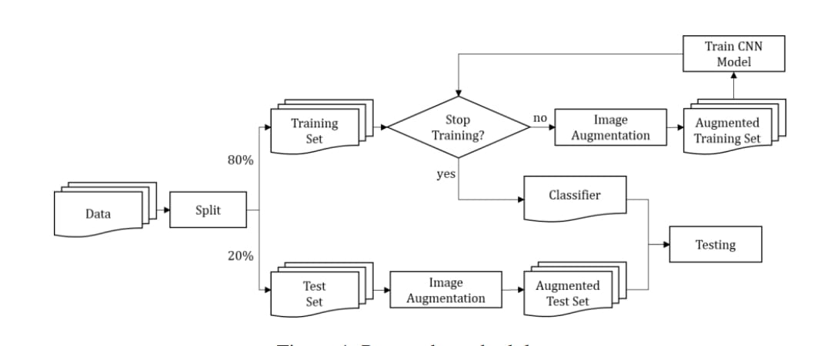

**Reference:** <https://beei.org/index.php/EEI/article/download/2385/1506>